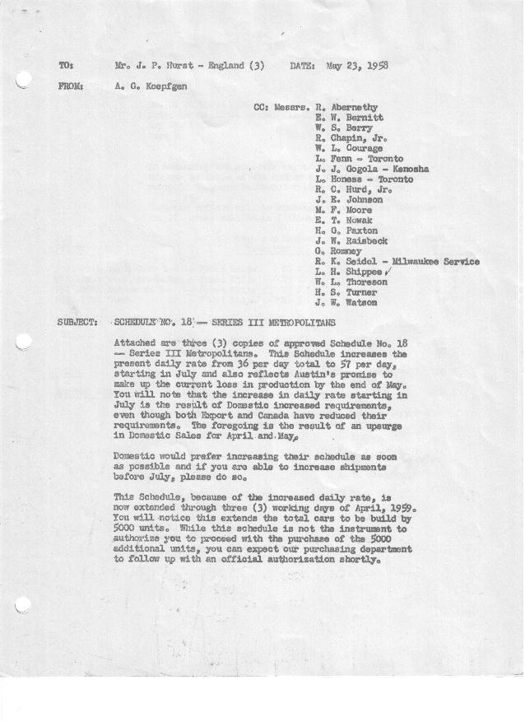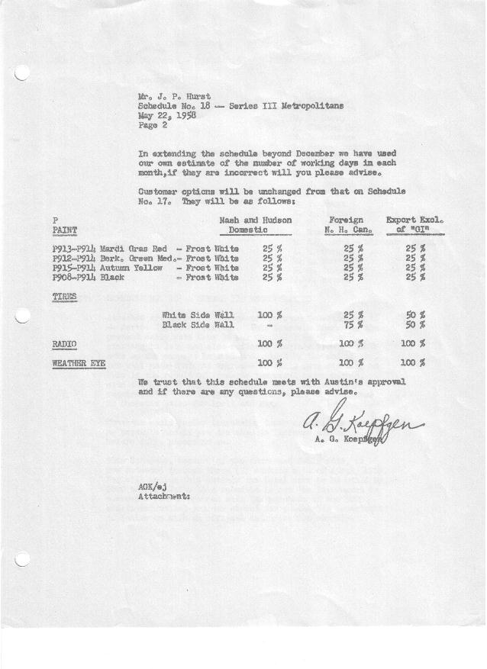

FORM AM 1262 Page 1 of 2 APPROVED R. Abernethy (signed) DATE 5-22-58

SCHEDULE NO. ______18 ___ DATE 5-21-58 MONTHLY BUILDING SCHEDULE APPROVED E.W.Bernitt (signed) ___ _DATE_ 5-23-58 _
REVISION NO. _______ ______ DATE PRODUCT APPROVED R. W.Chapin Jr. (signed) DATE _ 5-23-58 ____
SERIES III 1500 c.c. ENGINE
METROPOLITAN SERIES CARS – AUSTIN MOTORS CO., LTD, ENGLAND
DESCRIPTION | BUILT  ◻ACT EST  THRU  APRIL | FIRM BUILDING SCHEDULE  (FABRICATED MATERIAL RELEASE) |  |  |  |  |  |  |  |  |  |  |  |  |  |  | TENTATIVE SCHEDULE  (RAW MATERIAL RELEASED) |  |  | GRAND  TOTAL
DESCRIPTION | BUILT  ◻ACT EST  THRU  APRIL | MONTH May  DAYS 20 |  |  | MONTH June  DAYS 21 |  |  | MONTH July  DAYS 19 |  |  | MONTH August  DAYS 15 |  |  | MONTH September  DAYS 22 |  |  | MONTH October  DAYS 23 |  |  | GRAND  TOTAL
DESCRIPTION | BUILT  ◻ACT EST  THRU  APRIL | DAILY | MONTH | CUM’L  TOTAL | DAILY | MONTH | CUM’L  TOTAL | DAILY | MONTH | CUM’L  TOTAL | DAILY | MONTH | CUM’L  TOTAL | DAILY | MONTH | CUM’L  TOTAL | DAILY | MONTH | CUM’L TOTAL | GRAND  TOTAL
DOMESTIC LHD:
Hard-Top | 21637 |  | 568 | 22205 |  | 509 | 22714 |  | 883 | 23597 |  | 692 | 24289 |  | 983 | 25272 |  | 1054 | 26326
Soft-Top | 3495 |  | 199 | 3694 |  | 121 | 3815 |  | 120 | 3935 |  | 94 | 4029 |  | 121 | 4150 |  | 117 | 4267
Total U.S. | 25132 | 38.3 | 767 | 25899 | 30.0 | 630 | 26529 | 52.8 | 1003 | 27532 | 52.4 | 786 | 28318 | 50.2 | 1104 | 29422 | 50.9 | 1171 | 30593
Over/(Under) Schedule 17 | (167) |  | 167 | -0- |  | -0- | -0- |  | 433 | 433 |  | 336 | 769 |  | 444 | 1213 |  | 481 | 1694
FOREIGN:
EXPORT LHD Hard-Top | 704 |  | 25 | 729 |  | 35 | 764 |  | 35 | 799 |  | 35 | 834 |  | 35 | 869 |  | 35 | 904
Soft-Top | 327 |  | 12 | 339 |  | 15 | 354 |  | 15 | 369 |  | 15 | 384 |  | 15 | 399 |  | 15 | 414
Total Export LHD | 1031 |  | 37 | 1068 |  | 50 | 1118 |  | 50 | 1168 |  | 50 | 1218 |  | 50 | 1268 |  | 50 | 1318
RHD Hard Top | 343 |  | 13 | 356 |  | 12 | 368 |  | 20 | 388 |  | 12 | 400 |  | 20 | 420 |  | 12 | 432
Soft Top | 58 |  | 4 | 62 |  | 3 | 65 |  | 5 | 70 |  | 3 | 73 |  | 5 | 78 |  | 3 | 81
Total Export RHD | 401 |  | 17 | 418 |  | 15 | 433 |  | 25 | 458 |  | 15 | 473 |  | 25 | 498 |  | 15 | 513
Total Export LHD & RHD | 1432 | 2.7 | 54 | 1486 | 3.1 | 65 | 1551 | 3.9 | 75 | 1626 | 4.3 | 65 | 1691 | 3.4 | 75 | 1766 | 2.8 | 65 | 1831
Over/(Under) Schedule 17 | (120) |  | (16) | (136) |  | (5) | (141) |  | 13 | (128) |  | 19 | (109) |  | (41) | (150) |  | (33) | (183)
CANADA Hard-Top | 2287 |  | 51 | 2338 |  | 52 | 2390 |  | -0- | 2390 |  | -0- | 2390 |  | 70 | 2460 |  | 70 | 2530
Soft-Top | 209 |  | 22 | 231 |  | 9 | 240 |  | -0- | 240 |  | -0- | 240 |  | -0- | 240 |  | -0- | 240
Total Canada | 2496 | 3.7 | 73 | 2569 | 2.9 | 61 | 2630 | 0.0 | -0- | 2630 | 0.0 | -0- | 2630 | 3.2 | 70 | 2700 | 3.1 | 70 | 2770
Over/(Under) Schedule 17 | 31 |  | (31) | -0- |  | -0- | -0- |  | (63) | (63) |  | (51) | (114) |  | 45 | (69) |  | 20 | 249
Total Foreign | 3928 | 6.4 | 127 | 4055 | 6.0 | 126 | 4181 | 3.9 | 75 | 4256 | 4.3 | 65 | 4321 | 6.6 | 145 | 4466 | 5.9 | 135 | 4601
Over/(Under) Schedule 17 | (89) |  | (47) | (136) |  | (5) | (141) |  | (50) | (191) |  | (32) | (223) |  | 4 | (219) |  | (13) | (232)
GRAND TOTALS
Hard-Top | 24971 | 32.9 | 657 | 25628 | 29.0 | 608 | 26236 | 49.3 | 938 | 27174 | 49.3 | 739 | 27913 | 50.4 | 1108 | 29021 | 50.9 | 1171 | 30192
Soft-Top | 4089 | 11.8 | 237 | 4326 | 7.0 | 148 | 4474 | 7.4 | 140 | 4614 | 7.4 | 112 | 4726 | 6.4 | 141 | 4867 | 5.9 | 135 | 5002
Total | 29060 | 44.7 | 894 | 29954 | 36.0 | 756 | 30710 | 56.7 | 1078 | 31788 | 56.7 | 851 | 32639 | 56.8 | 1249 | 33888 | 56.8 | 1306 | 35194
Over/(Under) Schedule 17 | (256) |  | 120 | (136) |  | (5) | (141) |  | 383 | 242 |  | 304 | 546 |  | 448 | 994 |  | 468 | 1462

FORM AM 1262 Page 2 of 2 APPROVED R. Abernethy (signed) DATE 5-22-58

SCHEDULE NO. ______18 ___ DATE 5-21-58 MONTHLY BUILDING SCHEDULE APPROVED E.W.Bernitt (signed) ___ _DATE_ 5-23-58 _
REVISION NO. _______ ______ DATE PRODUCT APPROVED R. W.Chapin Jr. (signed) DATE _ 5-23-58 ____
SERIES III 1500 c.c. ENGINE
METROPOLITAN SERIES CARS – AUSTIN MOTORS CO., LTD, ENGLAND
DESCRIPTION | BUILT  ◻ACT◻ EST  THRU | FIRM BUILDING SCHEDULE  (FABRICATED MATERIAL RELEASE) |  |  |  |  |  |  |  |  |  |  |  |  |  |  | TENTATIVE SCHEDULE  (RAW MATERIAL RELEASED) |  |  | GRAND  TOTAL
DESCRIPTION | BUILT  ◻ACT◻ EST  THRU | MONTH November  DAYS 20 |  |  | MONTH December  DAYS 21 |  |  | MONTH January, 1959  DAYS 22 |  |  | MONTH February  DAYS 20 |  |  | MONTH March  DAYS 22 |  |  | MONTH April  DAYS 3 |  |  | GRAND  TOTAL
DESCRIPTION | BUILT  ◻ACT◻ EST  THRU | DAILY | MONTH | CUM’L  TOTAL | DAILY | MONTH | CUM’L  TOTAL | DAILY | MONTH | CUM’L  TOTAL | DAILY | MONTH | CUM’L  TOTAL | DAILY | MONTH | CUM’L  TOTAL | DAILY | MONTH | CUM’L TOTAL | GRAND  TOTAL
DOMESTIC LHD
Hard-Top |  |  | 585 | 26911 |  | 681 | 27592 |  | 688 | 28280 |  | 573 | 28853 |  | 880 | 29733 |  | 142 | 29875
Soft-Top |  |  | 65 | 4332 |  | 76 | 4408 |  | 94 | 4502 |  | 143 | 4645 |  | 220 | 4865 |  | 36 | 4901
Total U.S. |  | 32.5 | 650 | 31243 | 36.0 | 757 | 32000 | 35.5 | 782 | 32782 | 35.8 | 716 | 33498 | 50.0 | 1100 | 34598 | 59.1 | 178 | 34776
Over/(Under) Schedule 17 |  |  | 50 | 1744 |  | 297 | 2041 |  | 782 | 2823 |  | 716 | 3539 |  | 1100 | 4639 |  | 178 | 4817
FOREIGN:
EXPORT LHD Hard-Top |  |  | 35 | 939 |  | 35 | 974 |  | 35 | 1009 |  | 35 | 1044 |  | 35 | 1079 |  | -0- | 1079
Soft-Top |  |  | 15 | 429 |  | 15 | 444 |  | 15 | 459 |  | 10 | 469 |  | 6 | 475 |  | -0- | 475
Total Export LHD |  |  | 50 | 1368 |  | 50 | 1418 |  | 50 | 1468 |  | 45 | 1513 |  | 41 | 1554 |  | -0- | 1554
RHD Hard Top |  |  | 20 | 452 |  | 12 | 464 |  | 20 | 484 |  | 12 | 496 |  | 20 | 516 |  | -0- | 516
Soft Top |  |  | 5 | 86 |  | 3 | 89 |  | 5 | 94 |  | 3 | 97 |  | 5 | 102 |  | -0- | 102
Total Export RHD |  |  | 25 | 538 |  | 15 | 553 |  | 25 | 578 |  | 15 | 593 |  | 25 | 618 |  | -0- | 618
Total Export LHD & RHD |  | 3.7 | 75 | 1906 | 3.1 | 65 | 1971 | 3.4 | 75 | 2046 | 3.0 | 60 | 2106 | 3.0 | 66 | 2172 |  | -0- | 2172
Over/(Under) Schedule 17 |  |  | (3) | (186) |  | (15) | (201) |  | 75 | (126) |  | 60 | (66) |  | 66 | -0- |  | -0- | -0-
CANADA Hard-Top |  |  | 77 | 2607 |  | 20 | 2627 |  | 15 | 2642 |  | 10 | 2652 |  | 85 | 2737 |  | -0- | 2737
Soft-Top |  |  | -0- | 240 |  | -0- | 240 |  | 10 | 250 |  | 15 | 265 |  | 50 | 315 |  | -0- | 315
Total Canada |  | 3.9 | 77 | 2847 | 1.0 | 20 | 2867 | 1.1 | 25 | 2892 | 1.3 | 25 | 2917 | 6.1 | 135 | 3052 |  | -0- | 3052
Over/(Under) Schedule 17 |  |  | 27 | (22) |  | 20 | (2) |  | 25 | 23 |  | 25 | 48 |  | 135 | 183 |  | -0- | 183
Total Foreign |  | 7.6 | 152 | 4753 | 4.1 | 85 | 4838 | 4.5 | 100 | 4938 | 4.3 | 85 | 5023 | 9.1 | 201 | 5224 |  | -0- | 5224
Over/(Under) Schedule 17 |  |  | 24 | (208) |  | 5 | (203) |  | 100 | (103) |  | 85 | (18) |  | 201 | 183 |  | -0- | 183
GRAND TOTALS
Hard-Top |  | 35.8 | 717 | 30909 | 35.6 | 748 | 31657 | 34.5 | 758 | 32415 | 31.5 | 630 | 33045 | 46.3 | 1020 | 34065 | 47.1 | 142 | 34207
Soft-Top |  | 4.3 | 85 | 5087 | 4.5 | 94 | 5181 | 5.6 | 124 | 5305 | 8.6 | 171 | 5476 | 12.8 | 281 | 5757 | 12.0 | 36 | 5793
Total |  | 40.1 | 802 | 35996 | 40.1 | 842 | 36838 | 40.1 | 882 | 37720 | 40.1 | 801 | 38521 | 59.1 | 1301 | 39822 | 59.1 | 178 | 40000
Over/(Under) Schedule 17 |  |  | 74 | 1536 |  | 302 | 1838 |  | 882 | 2720 |  | 801 | 3521 |  | 1301 | 4822 |  | 178 | 5000

